  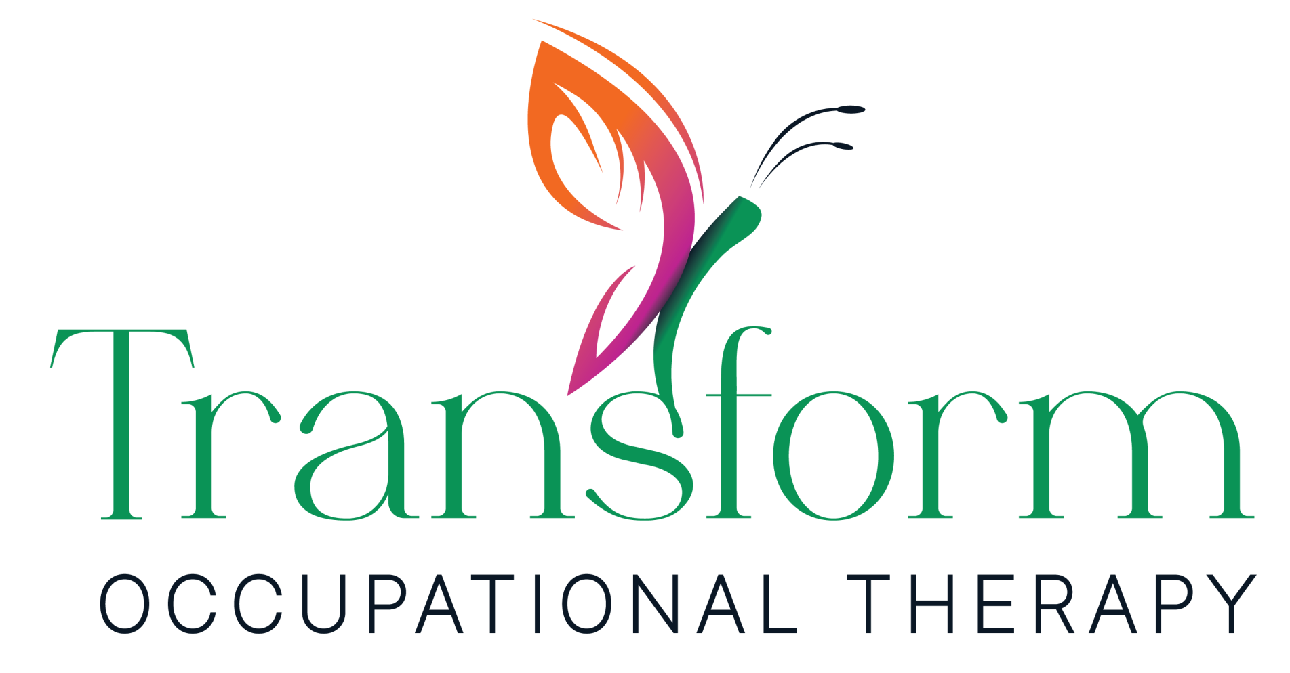  TRANSFORM OCCUPATIONAL THERAPY  AREAS OF EXPERIENCE  - Brain Injury  - Spinal Cord Injury  - Lower Limb Amputation  - Multi-Trauma  - Long term conditions such as MS, PD  - General elderly  SKILLS/EXPERIENCE  Heidi’s clinical background enables her to support clients with complex physical, cognitive, behavioural and psychological needs following serious injury or neurological illness.  In addition to working with adults who have sustained brain injuries, spinal cord injuries, stroke and progressive neurological conditions, she has experience of working with amputees and for those with pain issues relating to multi-trauma. She has extensive experience recruiting, training and supervising support teams, as well as undertaking comprehensive assessments to develop detailed care and rehabilitation recommendations, managing complex risk and advocating for clients throughout their rehabilitation journey. This has included vocational rehabilitation when required.  Heidi has held senior clinical leadership roles within specialist neuro-rehabilitation services and is experienced in coordinating multidisciplinary rehabilitation programmes.  She works collaboratively with therapists, legal teams, deputies, care providers and families to ensure rehabilitation interventions remain client-centred, evidence-based and focused on achieving positive outcomes.  With strong communication, creative problem solving and analytical skills, Heidi is committed to delivering high quality rehabilitation and responsive support that promotes independence, participation and quality of life for clients and their families.  CONTACT  0794 193 2470  Heidi.bowcher@transformot.co.uk;  South West England, West Midlands, South West and Wales  www.transformot.co.uk  QUALIFICATIONS, REGISTRATIONS AND MEMBERSHIPS  - BSc with distinction in Occupational Therapy, Queen Margaret College, 1991  - Health and Care Professionals Council (HCPC) member, reg 20129  - Royal College of Occupational Therapists (MRCOT) member  - British Association of Brain Injury and Complex Case Management (BABICM) member  - Institute of Registered Case Managers (IRCM) member reg 1882 | HEIDI BOWCHER BSc, MRCOT  NEURO SPECIALIST OCCUPATIONAL THERAPIST  LOCATION: SOUTH WEST, WEST MIDLANDS AND WALES  ABOUT HEIDI  Heidi is a highly experienced Occupational Therapist and Case Manager with more than 30 years of specialist clinical experience in neurological rehabilitation across both the NHS and private practice. She has worked with clients who have sustained traumatic and acquired brain injuries, spinal cord injuries, stroke and other complex neurological conditions, as well as a wide range of general conditions.  Heidi has extensive experience across acute, inpatient and community rehabilitation settings, combining specialist Occupational Therapy skills with holistic case management and multidisciplinary coordination. She is committed to delivering client-centred rehabilitation programmes that maximise independence, wellbeing and quality of life.  CAREER HISTORY  2013-PRESENT DAY INDEPENDENT NEURO-SPECIALIST OCCUPATIONAL THERAPIST  Heidi provides specialist occupational therapy assessment and rehabilitation for clients with complex neurological conditions and a wide range of general conditions. She works alongside case managers, rehabilitation companies, employers and private clients, providing specialist reports, rehabilitation plans, care guidance support, training and advice on equipment and adaptations within community, work and home settings.  2026-PRESENT DAY CASE MANAGER  EMMA WAY ASSOCIATES  Heidi joined Emma Way Associates in April 2026 to support clients who have sustained serious injuries and neurological conditions, including brain injury, spinal cord injury and with other complex neuro-rehabilitation needs.  2017-2025 NEURO-SPECIALIST CASE MANAGER  BROWNBILL ASSOCIATES  Heidi worked as a specialist neuro case manager supporting clients with complex neurological injuries and rehabilitation needs in both pre- and post-litigation cases. Her role included undertaking comprehensive Initial Needs Assessments, coordinating multidisciplinary rehabilitation programmes and working collaboratively with deputies, therapists, care providers and families to ensure high standards of client-centred support.  2014-2020 SENIOR / BAND 6 & 7 LOCUM NEURO-REHABILITATION OCCUPATIONAL THERAPIST POSITIONS  VARIOUS NHS TRUSTS AND SPECIALIST REHABILITATION SERVICES  Heidi worked across NHS and specialist neuro-rehabilitation services in multiple UK regions, providing acute and community rehabilitation for people with neurological conditions including patients with traumatic brain injury, stroke, spinal conditions and other complex neurological needs.  Responsibilities included cognitive, functional and environmental assessments, goal-based rehabilitation planning, vocational rehabilitation and discharge planning. Heidi worked closely with multidisciplinary teams and social care services while also contributing to service development, staff support and client-centred rehabilitation programmes. She also trained and worked as a DWP approved disability assessor for the PIP from 2014 to 2017.  1992-2014 VARIOUS NHS OCCUPATIONAL THERAPIST POSITIONS INCLUDING BAND 8A NEURO REHABILITATION CLINICAL SPECIALIST FROM 2003 TO 2006, AND FOUNDATIONAL NEURO SPECIALIST TRAINING AT NHNN, QUEEN SQUARE, LONDON  RECENT TRAINING  JUNE 2026 WEST MIDLANDS ACQUIRED BRAIN INJURY FORUM MEETING  A networking event with colleagues from across the region, presentations focusing on the world of Neurorehabilitation to support the recovery for those affected by an Acquired Brain Injury, hosted by Circle Rehabilitation.  MARCH 2026 WEST MIDLANDS ACQUIRED BRAIN INJURY FORUM MEETING  A networking event with colleagues from across the region, at the Resilience Therapy Centre, reviewing their neuro technology and presentations from a range of speakers from the MDT.  MARCH 2026 WORKING IN LITIGATION: A PRACTICAL GUIDE FOR CLINICAL TEAMS WEBINAR  Hosted by ABI Solutions with speakers Sarah Griggs and Lauren Hurney from Irwin Mitchell. Learning outcomes were the importance of keeping the client at the centre, and the value of MDT meetings, to invite legal team representatives to be able to help everyone involved to be on the same page to justify all the costs and needs for our client.  JANUARY 2026 AI MADE SIMPLE: PRACTICAL TOOLS FOR HEALTHCARE PROFESSIONALS WEBINAR  Hosted by ABI Solutions and presented by Tracey Clarke from Virtual Administration. Included various useful AI tools to increase efficiency as well as tools to help with client care and rehab.  ACHIEVEMENTS  - November 2025 – Joint speaker at the OT Show on the topic of faith and spiritual care, promoting the value of ensuring clients receive care that is sensitive and supportive to that person’s faith, beliefs and spiritual needs.  - 2015-2021 – Regional representative for the Royal College of Occupational Therapists Specialist Section for Neurological Practice (West).  - November 1998 – Paper co-published: Occupational Therapy for the Management of Fatigue in Multiple Sclerosis (British Journal of Occupational Therapy).
VALUES & INTERESTS
- Getting out and up a hill with her two lively dogs
- Any chance to sing- Heidi has sung in large choirs as well as small bands, and loves to harmonise!
- Heidi has a personal interest in how to encourage others to think on the deeper meaning of life. Her faith and faith community have been a source of identity, belonging and hope over many years

